Chapter 3
Research methodology
Introductory statement
This chapter discussed

Methodological Framework
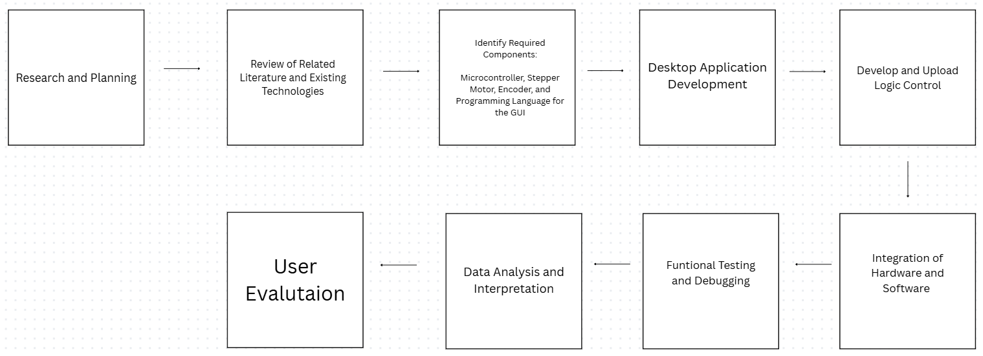
This framework summarizes the overall process involved in the development of a closed-loop stepper motor control system with UI for software configuration. The system aims to develop an accessible, locally made closed-loop stepper motor controller that assures motion control through real-time feedback and has a simple user interface for hardware configurations.

Following the initial framework, the process began with Research and Planning, where the researchers first of all they define the problem of a closed-loop motors and other stepper motors, They set the objectives, goals and outlined the technical roadmap of the project. Followed by the Review of Related Literature and Existing Technologies, studying previous studies and theories related to the stepper motors architecture.

Following the design stage, the researchers proceeded to the identity required components. This is where the researchers list all of hardware and software components that are needed in order to complete the system. After they identify and list the components the researchers moved to the next stage which is desktop application development. This is for coding the user-interface by creating a dashboard for monitoring and adjusting key parameters. The next stage is develop and upload logic control it is consist of code for the microcontroller to handle the feedback loop to the target command.

The next step was the integration of hardware and software, where wiring the motor and encoder starts, the use of usb for the communication between the hardware and the desktop user-interface. After that is functional testing and debugging, where the researchers need to thoroughly check the function of the motor and checking the UI if its display the correct position and parameters, debugging any noise that came from the encoder signal. Finally, The collected feedback was analyzed through data analysis and interpretation to evaluate the effectiveness of the system. The results can helped to determine whether the system was viable for a real-world environment.

Research Design
The study utilizes a mixed of quantitative and experimental research design. The researchers use quantitative because it relies on a numeric measurement for positional data, error margins, and response time for evaluating the functionality of the motors. They also used experimental, using this research design will help the researchers statistically for verifying the efficiently for eliminating some of the natural problem of a stepper motor.

Ethical Considerations
The process on developing and testing of the closed-loop stepper motor control system follows the strict rules of engineering safety standards for ensuring the protection of both the researchers and the equipment. First of all, the operational safety is maintained by implementing an emergency stop and software limits in the user interface for preventing a mechanical failure and injury during a high speed testing. For electrical integrity testing it is also prioritized by utilizing a stable power and insulated connections for mitigating a potential risk of overheating. Furthermore, the study maintains the principle of data integrity and objective report by documenting all experimental results and experimental failures. They are documented as a transparency for an honest performance of the closed-loop stepper motor control system prototype.

Data Collection Methods
The researchers follows the process of quantitative and experimental research design, by

